Green treasures from the magic mountains: the amazing story of Neolithic axeheads of jadeitite and other Alpine rocks
EDINBURGH ARCHAEOLOGICAL FIELD SOCIETY

on Wednesday 11 March 2026 at 7.00pm
at
at LG34 Paterson’s Land, Holyrood Road, EH8 8AQ
(part of Edinburgh University)
Mapping & Antiquities: Four Centuries of Myths, Mistakes and Misinformation
by
Chris Fleet, National Library of Scotland
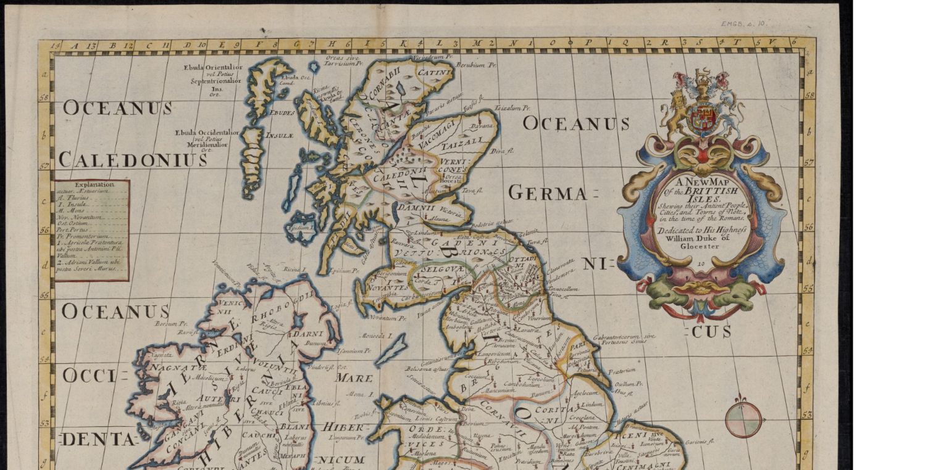
Book on Eventbrite or enquiries@eafs.org.uk

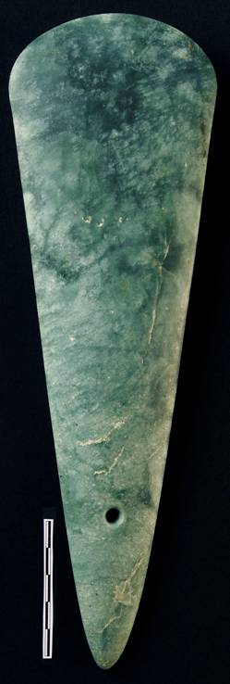
Visitors Welcome Suggested Donation £3.00
 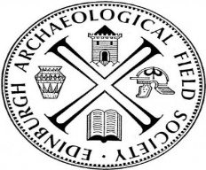  SCOTTISH CHARITY No 06520

