Castledykes Roman Fort – Ravenstruther

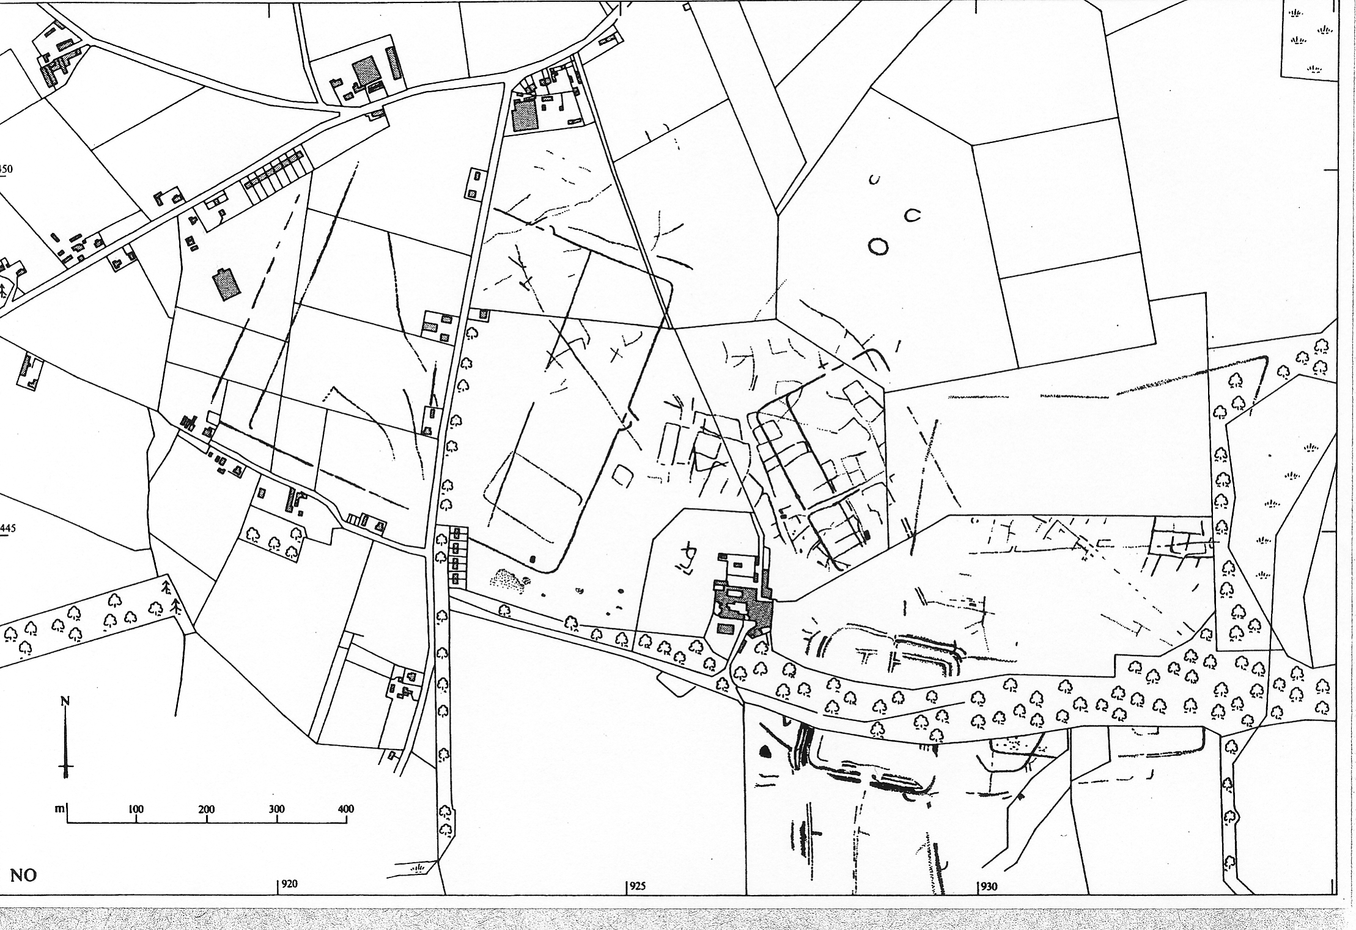

The area surrounding Castledykes Roman fort is historically one of the most interesting in the whole of Scotland. This is despite the fact that very little can be seen above ground.

However the story of the fort and its surroundings is being to emerge after almost two thousand years. This has happened as a result of academic research, fieldwalking, resistivity surveys, excavation and aerial photography.

The complexity of this story can be gauged by the map done by the Royal Commission for Historic Monuments Scotland which is based on a number of aerial photographs taken over the years..

Not only are there a bewildering collection of marching camps – three in total , there are many other features including several ring and ditch monuments belonging to Prehistoric times, field systems , a construction camp for the main fort and the main fort itself.

Before the marching camps and other features were revealed, only the fort itself was known. It was to be illustrated in General Roy’s work on the Roman Antiquities of Scotland.

Fieldwalking and Aerial photography have revealed that there was human occupation of the area surrounding the fort as far back as the Neolithic period roughly 4,500 years B.C. Flints and a limited amount of prehistoric pottery have been found. In addition the aerial photography has shown that there are several circular features near the site of the coal terminal. These have not been excavated but they probably date back to the Neolithic at the earliest but it is more likely that they date to the Iron Age.

THE ROMANS ARRIVE

Just about the time that the Romans arrived at Castledykes, there were two important Iron Age sites nearby. One of these is Cairngryffe – Hill Fort across the Clyde which in its day was a substantial hill fort and the other was the crannog site near Winston Barracks. The site is called Hyndford Crannog and it was occupied at the same time as the Romans came to Lanarkshire which is 79 A.D.

There is some debate now as to whether the Romans arrived before 79 A.D.
The only evidence to support this is some Roman Pottery called Black Samian. If further evidence turns up of this period , it would confirm the new theory that Agricola,s predecessor as Governor of Britain was the first Roman to mount an invasion of Scotland , his name was Petilius Cerialis.

The generally agreed date however is 79A.D – the Roman author Tacitus in his book –‘the Germania ‘ tells us that the Romans invaded Scotland under the leadership of a man called Agricola who came from Frejus in Southern France.

THE EVIDENCE

Aerial photography has revealed several marching camps; the one built by Agricola’s men had hook like defences (clavicula) and was about 45 acres in extent. It would house about 8,000 men and was divided into two parts – the smaller area being used for the horses/ pack animals and wagons.

A chance discovery of a lead seal belonging to the Ala Sebosiana at Castledykes and some letters from Carlisle relating to the same unit helps us to reconstruct the story of Castledykes. The letters tell us that one member of the unit was a senior member of Agricola’s staff belonging to the Equates Singulares or Governor’s bodyguard. The letters also tell us about the names of some of the troopers / the rations they drew for themselves and their horses.

The Sebosiana originally came from Gaul – modern day France – were originally recruited in the reign of Tiberius (A.D 14 – 37). Since they backed the wrong side in the Civil War after the death of Nero (A.D 64) , they were sent from their base in Mainz to Carlisle.

These men came from Gaul and were auxiliary soldiers – unlike Roman Legionaries , the auxilaries had to serve for twenty five instead of eighteen years. These soldiers were recruited from the areas that the Romans conquered and basically formed the backbone of the Roman Army. Despite this they were not as well paid as their Italian counterparts but as least , they got a pension. This was a major attraction as many ex members of the auxiliaries retired to set themselves up in business.

SETTLING IN

Aerial photography has revealed a smaller camp within the temporary camp and this may have been a temporary construction camp . The fort was probably built by a mixture of legionaries and auxilaries A stone found during Professor Anne Robertson’s excavation of the Headquarter’s building shows a Capricorn . This was the symbol of the Second Augustan Legion from Caerleon,

The fort was 7.8 acres in extent and housed up to 500 men . In the centre of the fort there was a stone H.Q and a granary building alongside it. These were found by excavation and recent resistivity work has revealed some of the barrack blocks which were probably built of stone.

Evidence found during fieldwalking has revealed coins both bronze and silver from the reigns of Vespasian , Titus and Domitian which cover the first period of the occupation of Castledykes. Also belonging to this period are the fragments of amphora which at one time contained wine and fish sauce, cooking pots and Samian Ware – a cherry coloured pottery imported from France.

RETREAT

During the reign of Domitian a decision was made to withdraw soldiers from Scotland to fight the Dacians in Romania in A.D 86. Though troops were not withdrawn from the Lowlands at this stage , there is evidence to suggest that about 103 A.D Trajan required yet more troops for Romania and the temporary defensive line in Southern Scotland was abandoned.

ROMANS RETURN

The Romans began to renew their interest in Scotland during the reign of Hadrian but it was not until the reign of the Emperor Antoninus Pius that the Romans began to renew their interest in Scotland. Antoninus sent his army into Scotland in 138 A.D a few months after the death of Hadrian,

The first phase of the re- occupation takes the form of a marching camp – there are two possible camps for this period. The larger is probably the one used first. The smaller was probably used as a construction camp for the reoccupation of the camp later in the reign of Antoninus Pius.

The Romans rebuilt the original camp and made it a bit larger. It was one of the most important Roman Forts in Southern Scotland , guarding the routes from East to West and North to South. It is generally accepted that the Roman name for Castledykes was Coria. This means ‘Meeting Place’ in English. This describes very well its function as a meeting place of the main roads in Southern Scotland. In modern terms it was like a motorway service station – outside the fort to the east was an enclosure where traders or the military could leave their animals and wagons.

LIFE IN THE FORT

The soldiers guarding the fort would probably be a mixture of cavalry and infantry . Finds made over the years have included bits of horse harness, decorations for the horse’s tails in blue glass as well as a spear.

Life for the soldiers was not too unpleasant as they were well supplied with wine / olive oil and garum. The last item was an unpleasant smelling fish head sauce that the Romans added to their food but curiously enough it tastes quite nice!

Evidence of the ovens where they cooked their food has been found , the ovens were rather like ovens traditionally used today in Cyprus , where the oven is warmed up first – the cinders raked out then the bread or meat or whatever was laid on the hot stones to cook.

The day to day pottery used by the soldiers was probably made in Scotland . However some of the fancier pieces were made elsewhere such as the Samian Ware . This fine cherry coloured pottery was made in Central France. It was made in moulds and was often decorated with designs taken from mythology or every day life.

Other interesting types of pottery included a type of pottery known as a mortarium – mixing bowl. This white pottery had quartz chips in the fabric so that the mixing bowl could be used for grating cheese / carrots etc. Coarser types of black and grey pottery were used for storage of salt / herbs etc as well as for cooking on a barbecue grill.

The Romans made use of glass both window glass and glass from drinking glasses has been found during fieldwalking, Glass was also used for the tear vases for the cemeteries but as yet the cemetery for Castledykes in the Roman Period has not been discovered.

Entertainment was limited but in 2008 a glass counter was found showing that the soldiers did play draughts , also it is likely that they played games of chance and gambled. There was little to spend their money on apart from the items bought to the camp by the traders. Some of the games of chance possibly took place in the bath house. As yet a bath house has not been found but such a large fort would have had a bath house. Tiles were found in 2006 which would be suitable for a bath house but further investigation is required.

Some of the silver denarii and bronze coins such as Sesterces have been found from this period. The troops were regularly paid though money was deducted for their pension / equipment and a major party at Christmas called the Saturnalia. Some of the money too made have found its way to the local people and indeed some of soldiers may have married or had local women as partners. Some of the finds such as bronze brooches may indicate the presence of women at Castledykes.

The soldiers would have their own medical staff – an ear scoop was found about twenty-five years ago which would have been part of the medical equipment they had. The Romans were the most advanced people in Western Europe up to the time of the Crimean War in terms of what they did for their soldiers. In the larger forts. one area was devoted to a hospital block.

The soldiers probably made many of the things that they needed from weapons as a result of smelting iron ore to the actual wooden defences of the fort. Evidence has been found of lead smelting, well clear of the Clyde and done by the Clyde. The lead seems to have been mined locally at Leadhills and this was many centuries before the monks appeared on the scene to do the very same thing. The position of the lead smelting facility a fair way from the fort shows that the Romans were even then aware of the toxic nature of lead fumes.

There would have been local families living nearby as aerial photographs show a complex field system possibly belonging to this period. The crops grown would be wheat and barley which were always needed by the Roman Army for their men and horses. Some of this would come from the locals in form of tax paid to the Romans.

Also animal husbandry was vital – cattle not only for their meat but for their hides which were used in the manufacture of everything from leather tents to shoes. Horse breeding too would be important to provide the steeds to patrol the roads and provide mounts for the Imperial Postal Service. A message using the Imperial post would if urgent take about a fortnight to reach Rome.

The presence of traders has been detected at Castledykes – lead weights of have been found; these range upwards of one ounce or uncia up to much larger ones weighing about one pound. Some of these would be used with a set of balances.

THE ROMANS LEAVE AGAIN

Castledykes was a vibrant community in the Antonine period but things were to change in the reign of Marcus Aurelius when there were pressures all along the Rhine / Danube frontier. That was not all as there is a recorded rebellion in Britain in 166 AD. This is a date that is accepted as a time that it was decided to pull back troops based in Scotland.

There was another major reason for pulling back from Scotland and that was the Black Death. This swept through the Roman Empire between 165-166 AD killing about a third of the population. Amongst the victims is thought to be Marcus Aurelius’s son in law Lucius Verus.

However the evidence surprisingly shows that the Romans remained in control. A silver denarius of Marcus Aurelius was found during excavations of the ring work in the High Parks at Hamilton which featured Salus – God of Health; this was struck after the plague had taken away Lucius Verus. This was not the only piece of evidence as a worn Sestertius of the Empress Lucilla was discovered . This was possibly lost after the Emperor Commodus ordered a retreat from Scotland in 186 A.D

THE LAST PART OF THE STORY

The Romans did attack Scotland in the reign of Septimius Severus – the last Roman Emperor known to have personally conducted a campaign in Scotland. The reason Severus came to Scotland was an attack made on Hadrian’s Wall by various tribes including the Caledonii ,this probably happened as a result of the Emperor Clodius Albinus taking troops from Britain to fight Severus for the right to be Emperor. This happened in 197A.D and by 207 A.D the Governor of Britain asked Severus for help to deal with the Caledonii. Severus came up to Scotland by sea and by the east coast. Unless new discoveries are made to show this was wrong, there is no evidence to show the Romans were at Castledykes for the campaign between 208 – 211 A.D.

After Severus’ campaign and the treaty made by his son Caracalla , the Romans did not feel the need to retain a presence Scotland, That all changed when the tribes of Scotland attacked the province of Britannia in 367 A.D ; the tribes of Scotland were now referred to collectively as the Picts. They joined up with the Saxons and Scots from Ireland and ravaged the whole of Britannia.

To deal with this the emperor Valentinian dispatched Count Theodosius , a Spaniard to deal with the crisis and he managed to defeat the barbarians and even recover a province which had been lost for many years. This was named Valentia after the emperors Valentinian and his brother Valens.

This may have been the South of Scotland which for many years had been lost to the Empire. The case for this was strengthened by the discovery of three bronze coins of the emperors Constantine , Julian and Procopius . The discovery of a coin of Procopius is particularly significant as he died in 366 A.D – one year before the great Barbarian Conspiracy. Could it be that the Romans occupied Castledykes for one last time.

After 367A.D it is known that the tribes of Southern Scotland became more well disposed to the Romans and started to become Christian. It is also known that the Romans traded with the people of Southern Scotland in four places and the old fort at Castledykes might have been one of these places because of its location. Several tiny late Roman coins have been discovered of these only one survives, the other completely disintegrated. Castledykes was not the only site where presence of traders was detected. , a find of a reduced silver silqua of the Emperor Valentinian II minted in Trier in 382 was found at Libberton about eight miles from Castledykes Then gradually the fort fell into decay and the stone was gradually plundered from the site and Castledykes vanished not to be rediscovered till the 17th century by antiquarians.

