Green treasures from the magic mountains: the amazing story of Neolithic axeheads of jadeitite and other Alpine rocks
EDINBURGH ARCHAEOLOGICAL FIELD SOCIETY

on Wednesday 13 May 2026 at 7.00pm
at
at LG34 Paterson’s Land, Holyrood Road, EH8 8AQ
Wicked Wild Wastes or Sunlit Uplands? Glencoe and Rannoch Moor in 17th and 18th Centuries
by
Dr. Edward Stewart, Archaeology Scotland
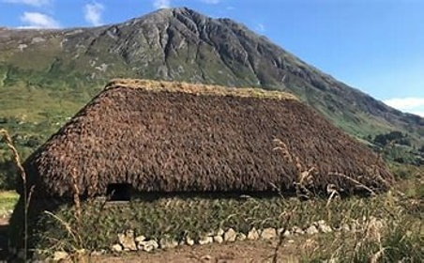
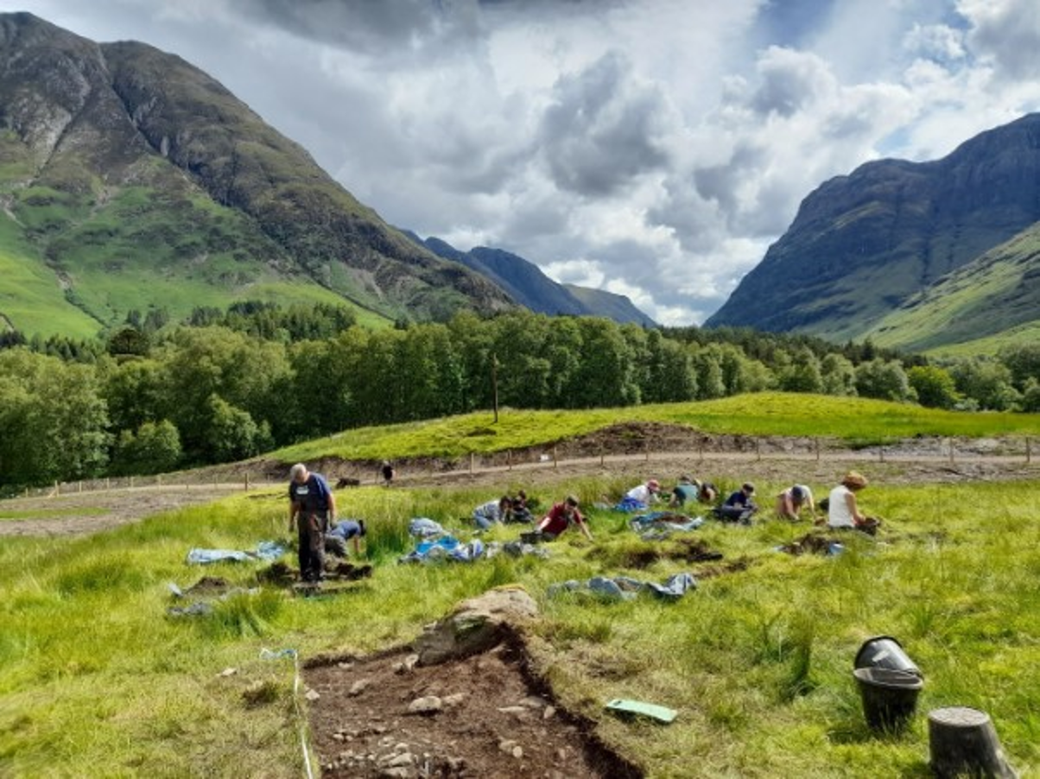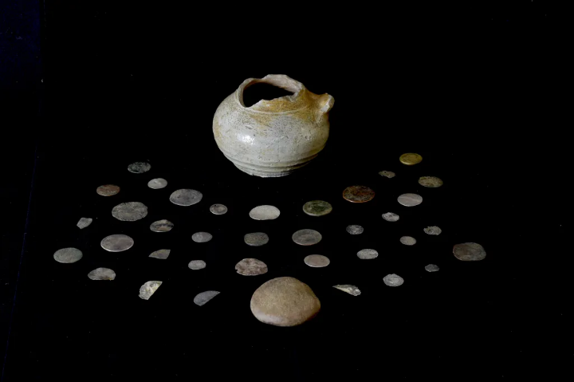
Book on Eventbrite
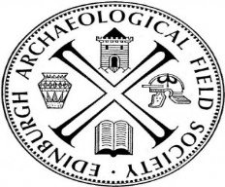
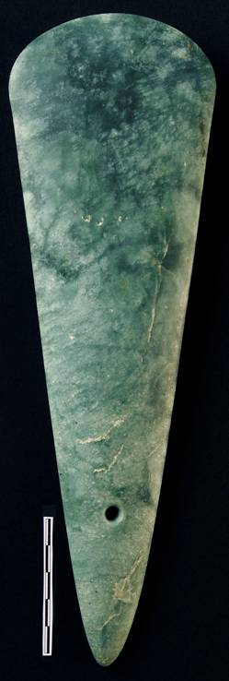
Visitors Welcome Suggested Donation £3.00
Scottish Charity No 06520

