PROGRAMMEOF TALKS 2024-25:

October 7th 2024

Eric Flack - Local Coalmines

October 21st

Alasdair Jamison – Battle of Mugdock AD 750

Nov 4th

Iain Murray – History of Shipbuilding on the Clyde

Nov 18th

Bill Gallacher – A History of Whisky at Glengoyne

December 9th

Members evening: quiz, refreshments

January 20th 2025

Severine Peyrichou – The Antonine Wall

February 3rd

Norry Wilson – Lost Glasgow

February 17th at 7 pm **A.G..,M.**  theb

Sam Gibson – Scotland’s Forgotten Canal

March 3rd

Stuart Gray – How to research your Family Tree

March 17th

Ian Shearer - From James Watt to John Brown: the dawn of steam power at Kinneil House and a personal navigation to Clydebank

Contacts:

E. Pitts

Chair

07879 246208

-

Dorothy Craig

Bookings secretary

0141 941 1074

-

Wilma Hinde

Treasurer

07952 542005

-

Website:

[www.clydebankhistory.org](http://www.clydebankhistory.org)

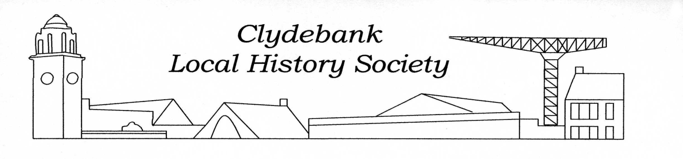

**CLYDEBANK LOCAL HISTORY SOCIETY**

West Dunbartonshire has an outstanding and continuous stream of history. To name just a few examples, the area contains carved cup and ring markings which are presumably from the Neolithic period; there are Iron Age remains in the area including the site of crannogs, and hill forts. Dumbarton Rock, (a volcanic plug from the Carboniferous period), has a long and eventful history. The Roman Antonine Wall came through to West Dunbartonshire, ending on the River Clyde at Old Kilpatrick. Old Kilpatrick has its own stories about a probable

Continued over/......

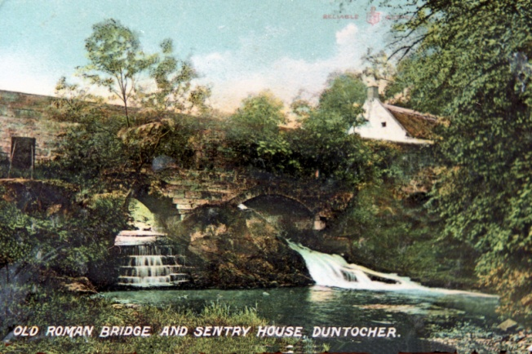

connection with St Patrick: there was a church there from the 12th century, and probably a good deal earlier.

The town of Clydebank itself came into being with the industrial age - the coming of the shipyards and other huge and thriving industries which continued until the mid-twentieth century.

The History Society’s stated aims are to create greater awareness of the history, culture and heritage of Clydebank and to encourage the preservation, development and improvement of features of general public amenity and historic interest.

The Society actively intervenes when we consider that our local heritage needs protection, or when it feels that it can contribute constructively to plans that include a local history context.

We run a series of ten lectures between October and March on a wide range of topics, not always ‘local’ history but always of historic interest and in a Scottish context. These are held at the Dalmuir Barclay Church Hall. We have a website - [www.clydebankhistory.org](http://www.clydebankhistory.org) through which we receive regular enquiries from the public on a great range of topics concerning Clydebank and area, and its inhabitants past and present.

We organise local outings to plac es of interest: for example in 2023 Society members visited Summerlee Industrial Park at Coatbridge, and the Kelvin Halls Museum Resource Centre in Glasgow.

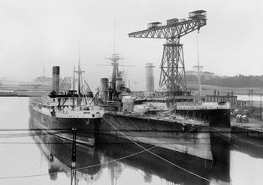

Clydebank shipyards

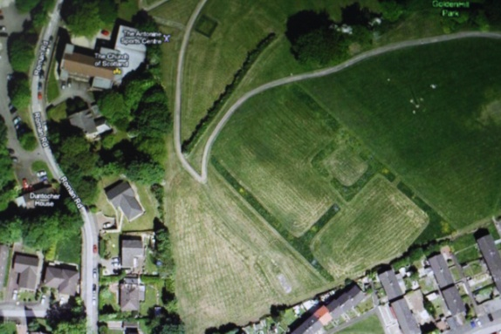

The site of the Roman fort at Duntocher

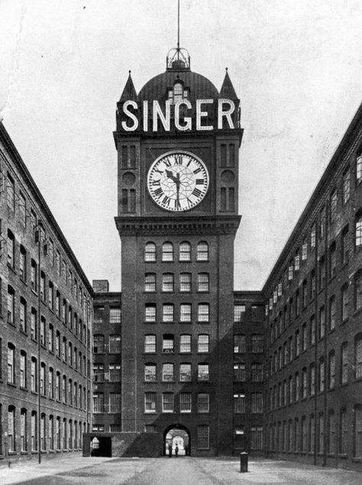

The Singer clock

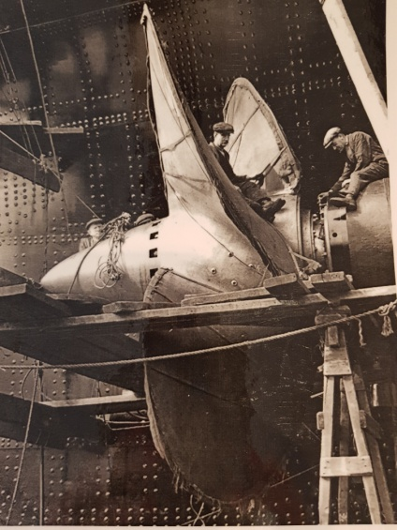

Fitting Queen Mary propeller 1934