AYRSHIRE ARCHAEOLOGICAL AND NATURAL HISTORY SOCIETY
SCO 44758

CONFERENCE
Saturday 10 October 2026, Harbour Arts Centre, Irvine.
Changing Ayrshire Landscapes

Registration from 10 a.m.

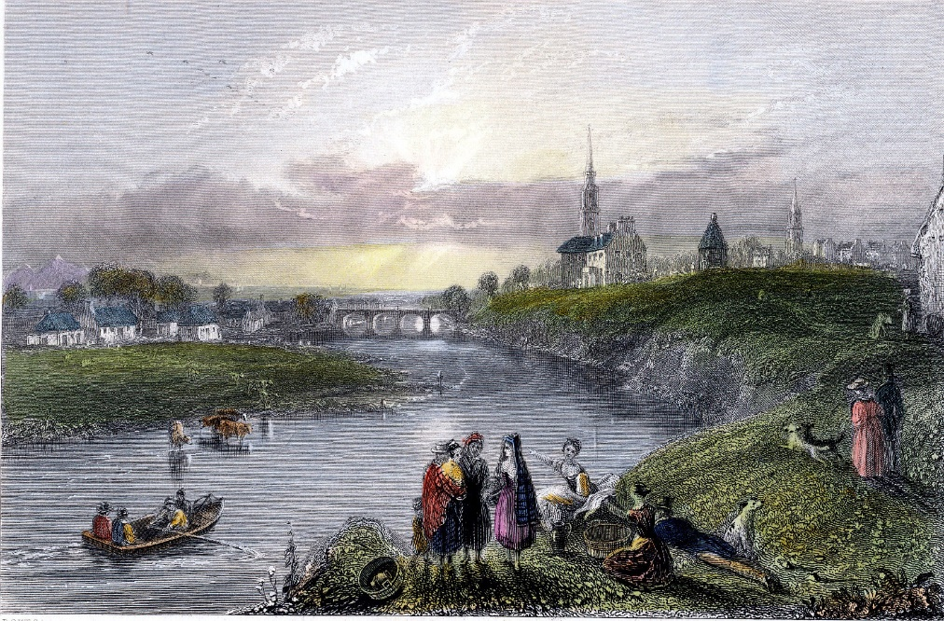

PROGRAMME
10.30 am Chair’s Welcome (Dr Ian Welsh OBE)
Morning Session: Townscapes and Energyscapes
10.45 am Dr Roan Rutherford: Irvine Harbour
11.15 am Joss Durnan: When the New Becomes the Old: Irvine New Town 30 years after Irvine Development Corporation
11.45 am Dr Ewan Gibbs: Ayrshire’s Evolving Energyscape: Coal, Nuclear and Renewables since the 1950s
12.15 am Lunch (own arrangements)
Afternoon Session: Rural Landscapes
2.00 pm Ailsa McInnes, Meiklewood: A Forgotten Ayrshire Landscape
2.30 pm Professor Annie Tindley: Sporting Estates and Landscape Change in Ayrshire, c.1850-2000

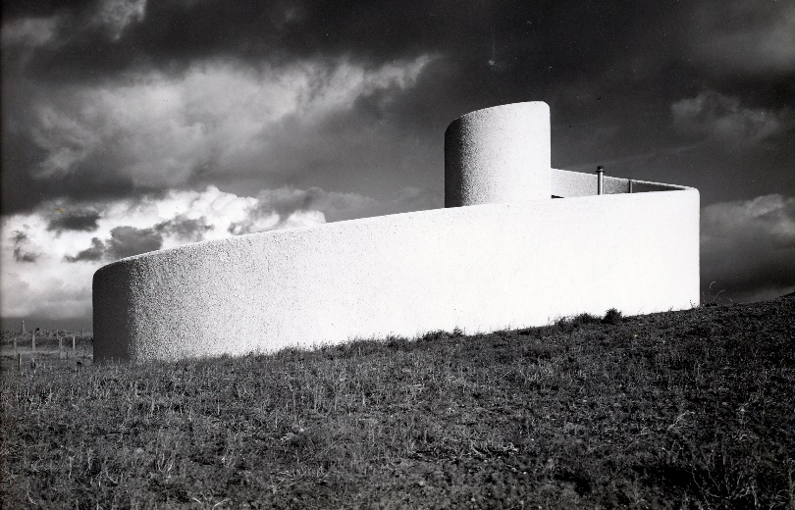

Our speakers
Dr Ian Welsh OBE has a wealth of experience in the third sector, as well as in teaching, academia, politics and local government. He was made an OBE in 2022 in recognition of his commitment to a range of causes and his dedicated work in the community.
Dr Roan Rutherford studied architecture at Edinburgh College of Art /Heriot Watt University and urban design at Edinburgh University, before becoming conservation architect in Irvine Development Corporation Planning Department. After the winding up of IDC in 1996, with other former IDC architects he set up Wren Rutherford Architects.
Joss Durnan is a Senior Ancient Monuments Officer at Historic Environment Scotland. Since 2018, he has spent his spare time researching Irvine New Town, how it confronts our definition of heritage, and the lasting effects that can have on communities.
Dr Ewan Gibbs is senior lecturer in Economic and Social History at the University of Glasgow. He is a historian of energy, industry, work and protest. He is the author of two books: CoalCountry: The Meaning and Memory of Deindustrialization (2021) and An Injury to All: The Unmaking of the British Working Class (2026).
Ailsa McInnes studied history at Edinburgh University, followed by several years of practical archaeology in Scotland and abroad. She now researches place and its people, concentrating on how a small area can fit into the bigger picture, giving a microcosm of Scottish History. She has published her research as The Lands of Drumfork.
Annie Tindley is Professor of British and Irish Rural History at Newcastle University. She researches land issues and rural history in the C19 and C20 in Scottish, Irish, and broader imperial contexts. She has published widely on questions of the aristocratic classes, landed estates and their management.

Booking Details
The cost of the conference is £10 per person.
The Conference can be booked through the Harbour Arts Centre, 116 Harbour Street (01294 274059) by phone, in person or through their website (thehac.co.uk). Tickets will also be available on the day of the event.
HAC is situated at the harbour in Irvine. It is a 5-10 minute walk from Irvine Train Station, and 15 – 20 minutes from the bus hub at Irvine Cross. There are a variety of pubs and cafes in the vicinity, including a restaurant (Duncan’s) within the centre itself.
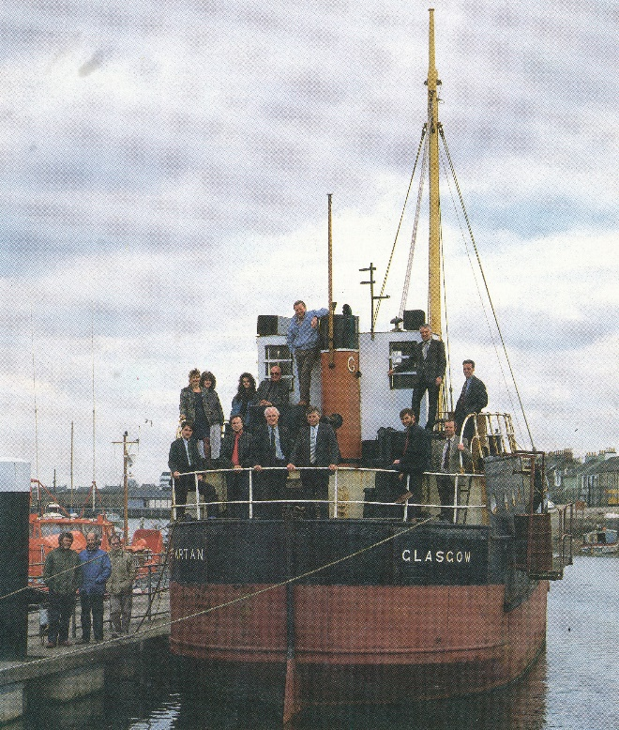
IDC ARCHITECTURE DEPARTMENT 1989

