Green treasures from the magic mountains: the amazing story of Neolithic axeheads of jadeitite and other Alpine rocks
EDINBURGH ARCHAEOLOGICAL FIELD SOCIETY

on Wednesday 12 November 2025 at 7.00pm
at
at LG34 Paterson’s Land, Holyrood Road, EH8 8AQ
(part of Edinburgh University)
Clyde Wind Farm Project
By Kirsty Dingwall
Headland Archaeology
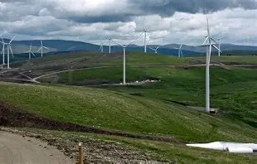
Book on Eventbrite or enquiries@eafs.org.uk

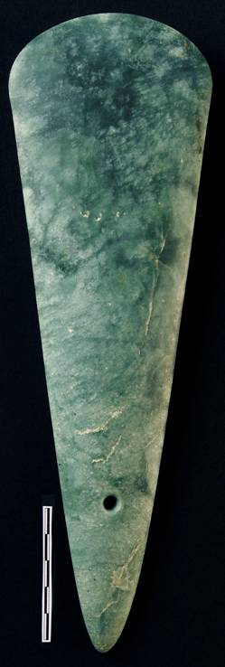
Visitors Welcome Suggested Donation £3.00
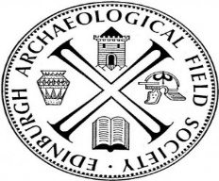
Scottish Charity No 06520

