Edinburgh Archaeological Field Society
Doors Open Day 2024
at
CAMMO ESTATE
Sunday 29 September

WALKING TOURS at 10.30 AM AND 1.30 PM
Take part in the excavation, learn about the characters and see our finds
Meet at Cammo Lodge, Cammo Road, EH4 8AW
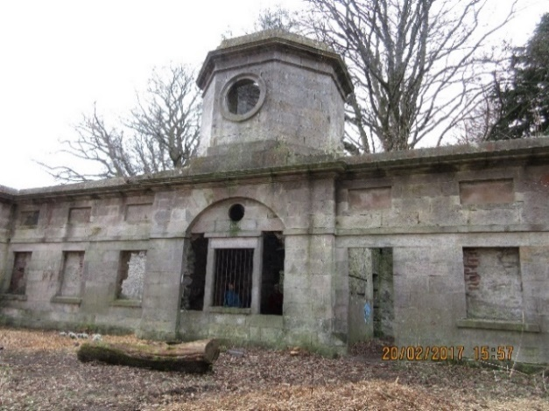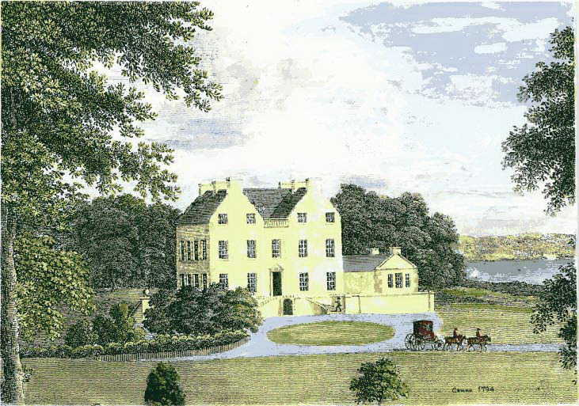
Contact volunteer@eafs.org.uk to book a place.

 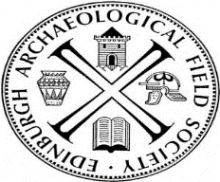Scottish charity No. SC006520

