**KINLOCHARD LOCAL HISTORY GROUP 24/25 PROGRAMME**

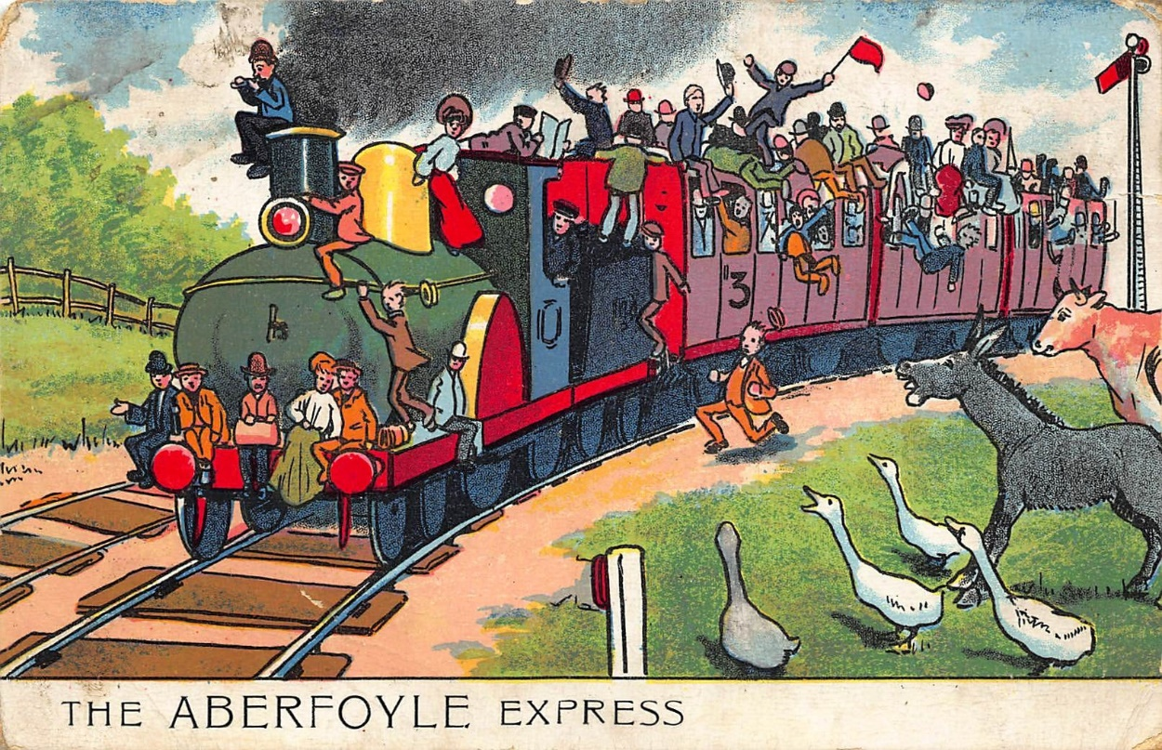

**Venue Kinlochard Village Hall: Meeting Time 7.30 pm**

**Wednesday 02 October 2024**

Robert Sharp: The Early History of Scottish Mountain Rescue.

**Wednesday 06 November 2024**

Walter Semple : The Deep History of the Local Landscape

**Wednesday 04 December 2024**

Nigel Bonnet: A Short history of Bridge of Chon House...and its natural history

**Wednesday 8 January 2025**

Mike Benson: Development of the New Scottish Crannog Centre

**Wednesday 05 February 2025**

Louise Nixon: Every Contact Leave a Trace

**Wednesday 05 March 2025**

Don Martin: Last Train to Aberfoyle

**Wednesday 02 April 2025**

Professor Richard Oram: The Early Burgh of Stirling

**Annual Membership £15 or £4 per presentation**

**Contact Joyce Kelly (Secretary) Tel 01877 387292 James Kennedy (Chair) Tel 01877 387201**

**For Subscriptions Katy Lamb** [**K.lamb142@btinternet.com**](mailto:K.lamb142@btinternet.com) **– Bank Transfers preferred**

**Loch Ard Local History Group 80-05-91 00370858**