Edinburgh Archaeological Field Society
Open Day
at
CAMMO ESTATE

Saturday 16 August

WALKING TOURS at 10.30 AM AND 1.00 PM
Take part in the excavation, learn about the characters and see our finds
Meet at Cammo Lodge, Cammo Road, EH4 8AW
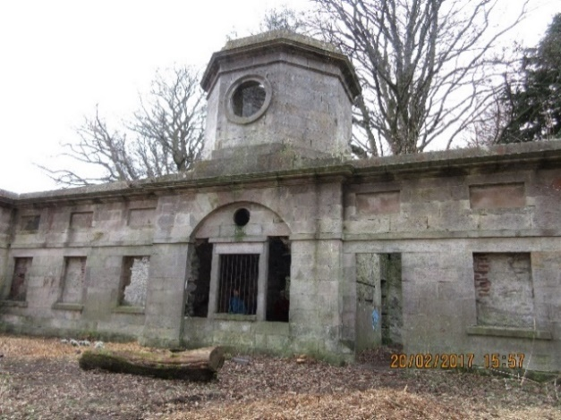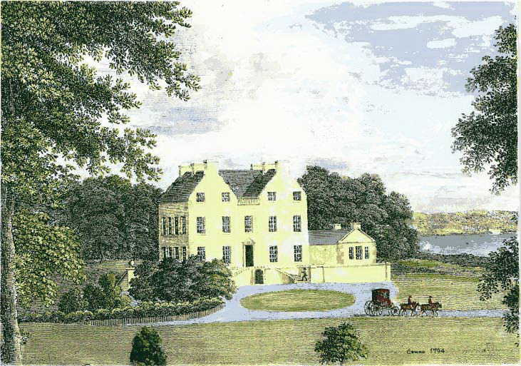
Contact volunteer@eafs.org.uk to book a place.

 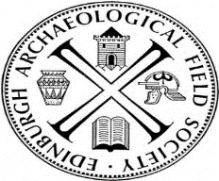Scottish charity No. SC006520

